Campus Event Scheduler System

The Campus Event Scheduler System is a web-based application designed to help manage and organize campus events efficiently. The system allows students and faculty members to log in, view upcoming campus events, and send feedback regarding events they attended. This provides a centralized platform where users can stay informed about campus activities and share their experiences or suggestions to improve future events.

On the administrative side, the system allows the admin to securely log in and manage the overall event process. The admin can create student accounts, create new events, update event details, delete events when necessary, and manage the overall event schedule to prevent conflicts. This ensures that campus events are well-organized, properly scheduled, and effectively monitored.

Actors / Users

- Student
- Admin

Main system Function
Student / Faculty:
- • Login
- • View Campus Events
- • Sent Feedback

Admin:
- • Admin Login
- Create Student Account
- • Create Event
- • Update Event
- • Delete Event
- • Manage Event Schedule

UML Diagram(Use Case)
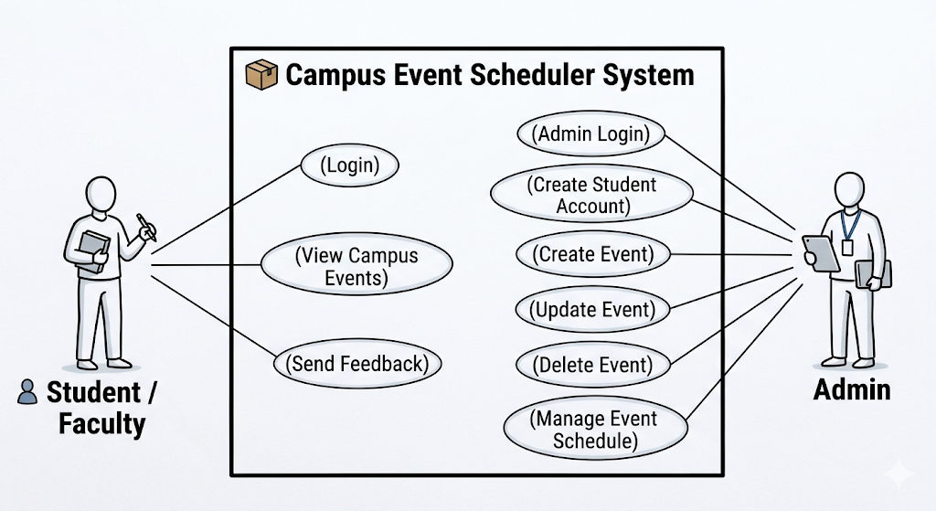

The Campus Event Scheduler System serves as a centralized platform for managing university activities between two distinct user groups. Students and faculty use the system to access event information and provide feedback, while administrative users handle the backend logistics of scheduling and account creation. The system boundary clearly separates these user interactions from the internal software processes. This layout ensures that responsibilities—from viewing schedules to managing "CRUD" operations—are clearly defined for a streamlined campus experience.

